-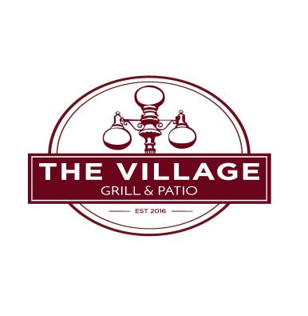
STARTERS
POTATO SKINS ……………….……..5.99
ONION RINGS ……………. SIDE 3.75…………………… BASKET 5.99
BREADED MUSHROOMS ………… 3.75
BARE CHICKEN WINGS ………6 FOR 4.99……….. 12 FOR 8.49
WING DINGS ………….6 FOR 4.50 ………… 12 FOR 7.99
CHICKEN DIVOTS …HAND CUT, BREADED..1/2 LB…5.49 ..1 LB..9.49
HOT PEPPER CHEESE BALLS ………………………. 3.75
MOZZARELLA STICKS ……………………. 4.99
CHEESE QUESADILLAS ………4.99 ADD CHICKEN ………… 6.49
STREET TACO MEAT, LETTUCE, CHEESE ,TOMATO, AND ONION 1.99 OR 3 FOR 5.00
FRESH CUT FRIES …………. SIDE 2.49…… BASKET 4.99………CHEESEY FRIES…… 5.99
SAMPLER BASKET …ONION RINGS, MUSHROOMS, FRENCH FRIES, CHEESE BALLS, MOZZARELLA STICKS, AND DIVOTS…………… 9.99
SANDWICHES SERVED WITH CHIPS
SUB FRIES WITH ANY SANDWICH FOR 1.49 ADD CHEESE .50 BACON 1.00 MUSHROOMS 1.00 JALEPENO .50 SAUTEED PEPPERS .50 SAUTEED ONIONS .50
OLD FASHION BURGER LETTUCE ,TOMATO AND ONION 6.49
OUTLAW BURGER BACON, ONION RINGS, CHEESE & BBQ SAUCE 8.49
GRILLED CHEESE GRILLED GOLDEN ON BREAD 4.99
HOT HAM AND CHEESE GRILLED GOLDEN ON BREAD 5.99
TURKEY REUBEN. TURKEY, SWISS CHEESE, COLE SLAW, 1000 ISLAND ON RYE 7.49
CHICKEN SANDWICH GRILLED OR FRIED, LETTUCE AND TOMATO 7.49
BLT BACON, LETTUCE, TOMATO AND MAYO 5.99
CLUB SANDWICH TURKEY, HAM, BACON, LETTUCE, TOMATO, MAYO 6.99
PERCH SANDWICH LAKE ERIE PERCH WITH TARTAR SAUCE 8.99
PERCH BASKET 1/2 LB LAKE ERIE PERCH, WITH FRIES, AND COLE SLAW 12.99
HALF RACK OF RIBS FRIES AND COLE SLAW (WEDNESDAY, THURSDAY AND FRIDAYS) 11.99
SALADS
GRILLED OR FRIED CHICKEN BREAST FRESH GREENS, CHEESE, BACON, TOMATO, HARD BOIILED EGG 8.99
BALSAMIC SALAD…GREENS, SHRIMP OR CHICKEN, STRAWBERRIES(SEASONAL),
FETA CHEESE, ALMONDS AND A BALSAMIC REDUCTION. 9.99
CHEF SALAD TURKEY, HAM, TOMATO, CHEESE, EGG, GREEN PEPPER, ONION 8.99
TACO SALAD LETTUCE, TOMATO,CHEESE, TORTILLA CHIPS AND TACO MEAT 6.99
SIDES
COLE SLAW 1.99 APPLESAUCE 1.99 COTTAGE CHEESE 1.99 SIDE SALAD 2.99
BAKED POTATO 3.49 LOADED 4.49 (FRIDAYS ONLY)
VEGETABLE OF THE DAY 2.99 BROWN RICE 2.99 (FRIDAYS ONLY)
FRIDAYS ONLY
SMOTHERED CHICKEN BREAST TWO BONELESS BREASTS TOPPED WITH SAUTEED PEPPERS, ONION, MUSHROOMS AND CHEESE WITH 2 SIDES 12.99 STEAK ASK YOUR SERVER FOR THE STEAK OF THE WEEK, SEASONED TO PERFECTION OVER AN OPEN FLAME GRILL WITH TWO SIDES 16.99 GRILLED SALMON … HOUSE SPICE, OR CAJUN SERVED WITH TWO SIDES 17.99
WEEKLY DINNER SPECIAL…… ASK YOUR SERVER
CONSUMING RAW OR UNDERCOOKED MEATS, POULTRY, SEAFOOD, SHELLFISH, OR EGGS MAY INCREASE YOUR RISK OF FOOD BORNE ILLNESS.

